# File permissions in Linux

## Project description

Using Linux commands, we will view the permissions of files, hidden files and directories. ls command will be used to achieve the mentioned task. Furthermore, using chmod commands the permissions of files and directories can be changed.

## Check file and directory details

The command used to check the permissions of files and directories is ls -la ls is used to list all the files and directories and -l is an option that displays permissions whereas, -a option is used to display hidden files. They can be used in combination as -la to display permissions of all files and directories including the hidden files.

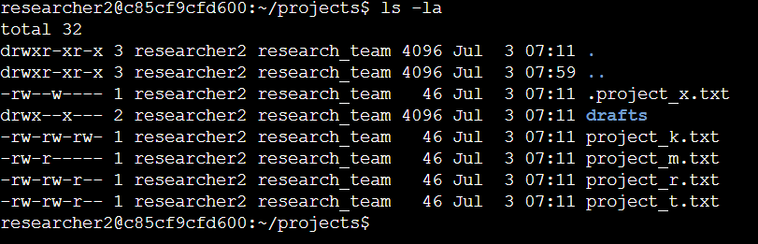

## Describe the permissions string

When we look at the line mentioning details about the “drafts” directory we notice a 10-character string “drwx--x---". The first character ‘d’ in this string means directory. The next three characters ‘rwx’ describe the permissions for the user. Here, r-read, w-write, x-execute. This means, User has all three permissions for the directory draft. Next three characters “--x” depict permissions for the Group and last three characters “---” depict permission for others.

## 

## Change file permissions

It can be observed that project_k.txt has write permissions for other groups. Which violates the principle of least privilege. Hence, we will use the command chmod o-w project_k.txt to remove the write permission. In the first argument ‘o-w’ o stands for other groups and -w depicts the removal of write permissions. The second argument is the file name.

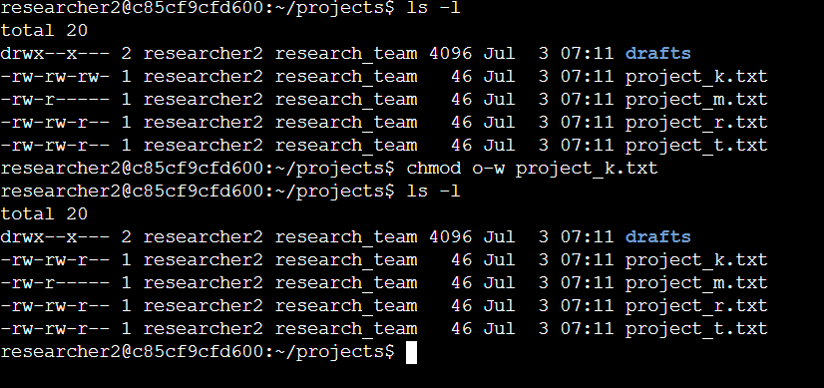

## 

## 

## 

## Change file permissions on a hidden file

To view the permissions of hidden files, we use the command ls -la. We can observe from the 10-character string that the hidden file .project_x.txt has write permissions for user and group. To change the permissions we will use the command chmod u-w,g=r .project_x.txt . This command will update the permissions so that both user and group only have the read permissions to the hidden file.

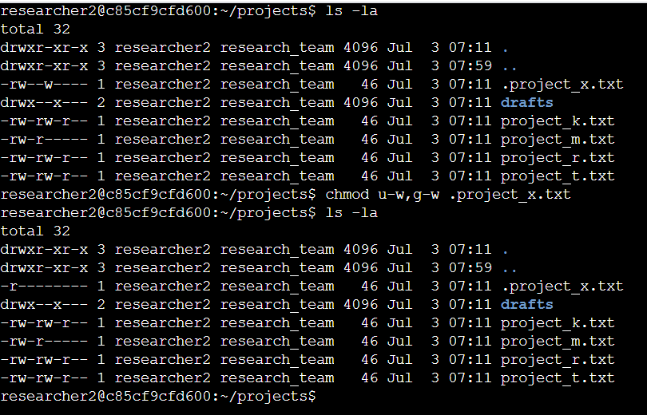

## Change directory permissions

It can be observed that group type have the permission to drafts directory. This directory belongs to the researchers2 only. Hence, this permission needs to be revoked in order to align with the principle of least privilege. To update the permissions we use the command

Chmod g-x drafts.

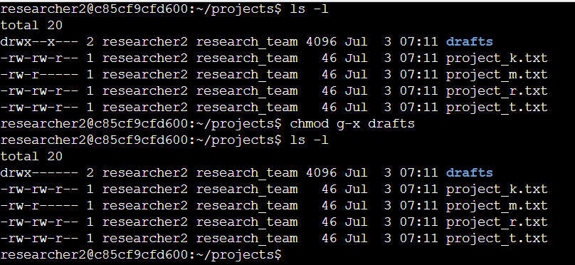

## Summary

Using several linux commands, the permissions of certain files, directories and hidden files have been updated correctly in order to align with the principle of least privilege. As a result, the security of files and systems have been improved significantly.